在学信网查询学籍、学历信息的方法
INFORMATION OF STUDENT STATUS AND ACADEMIC DEGREE CREDENTIALS VERIFICATION METHOD

1. 登陆学信网网站(http://www.chsi.com.cn/)。
Log on to the China Credentials Verification website. (http://www.chsi.com.cn/)

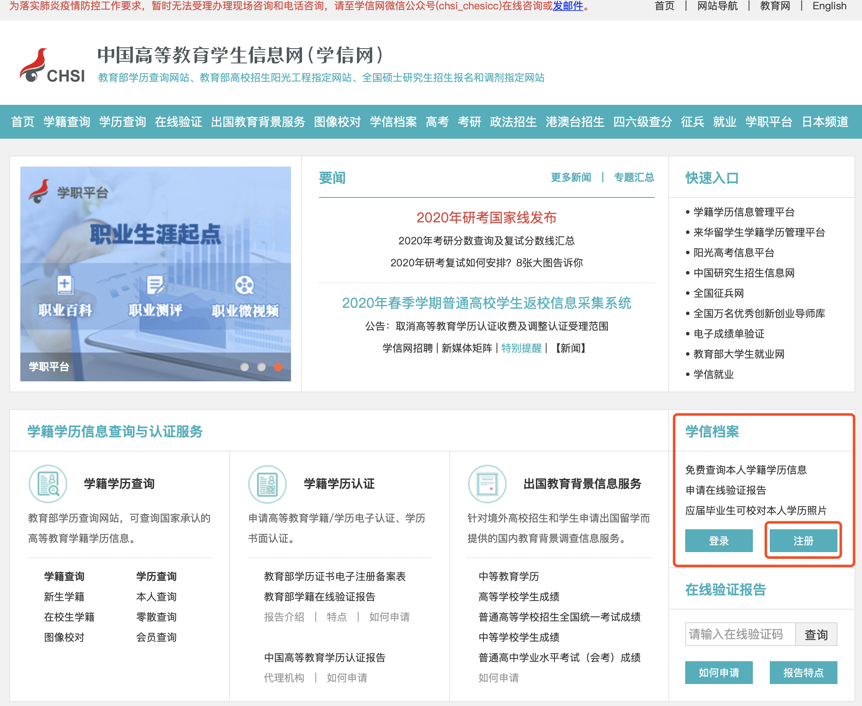

2.注册学信网账号 | Register a CHSI account
在“学信档案”处点击“注册”。| Click on “注册” at the“学信档案”area.

注册时一定要注意 | When registering, be sure to：
(1)证件类型选择“Other”（其他）。| Select “Other” as the type of ID.
(2)姓名请按照学生证上的英文姓名格式和顺序来填写。| Fill in the English name as it is on your student ID.

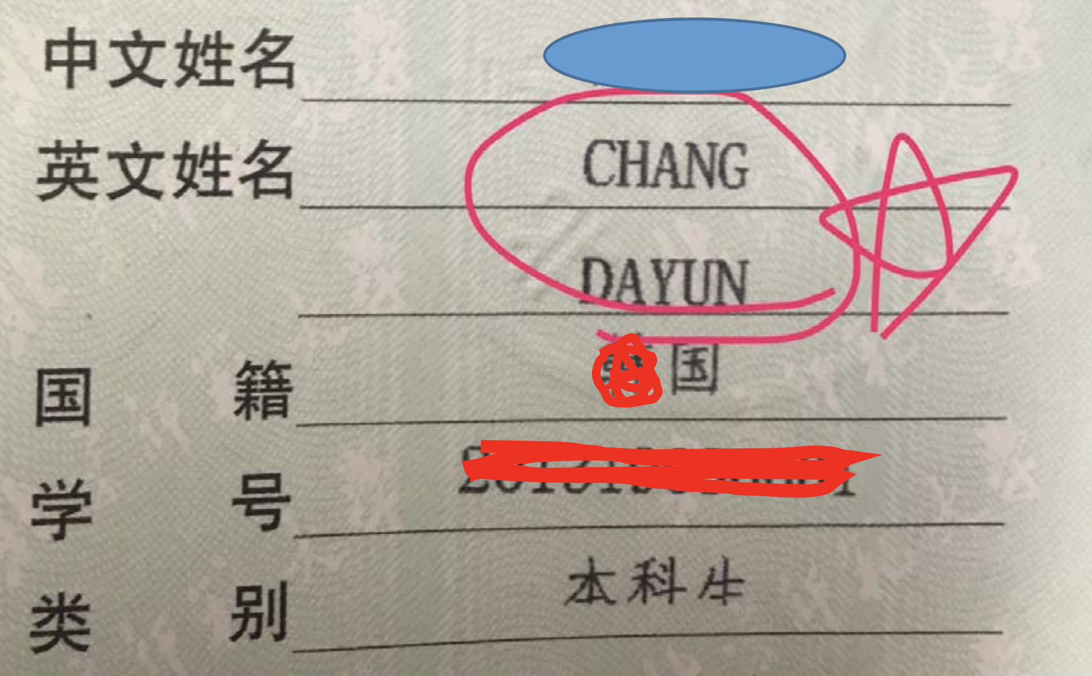
(3)一定要填写自己入学时的护照号码。
Fill in your passport number you used when you were admitted into the school.
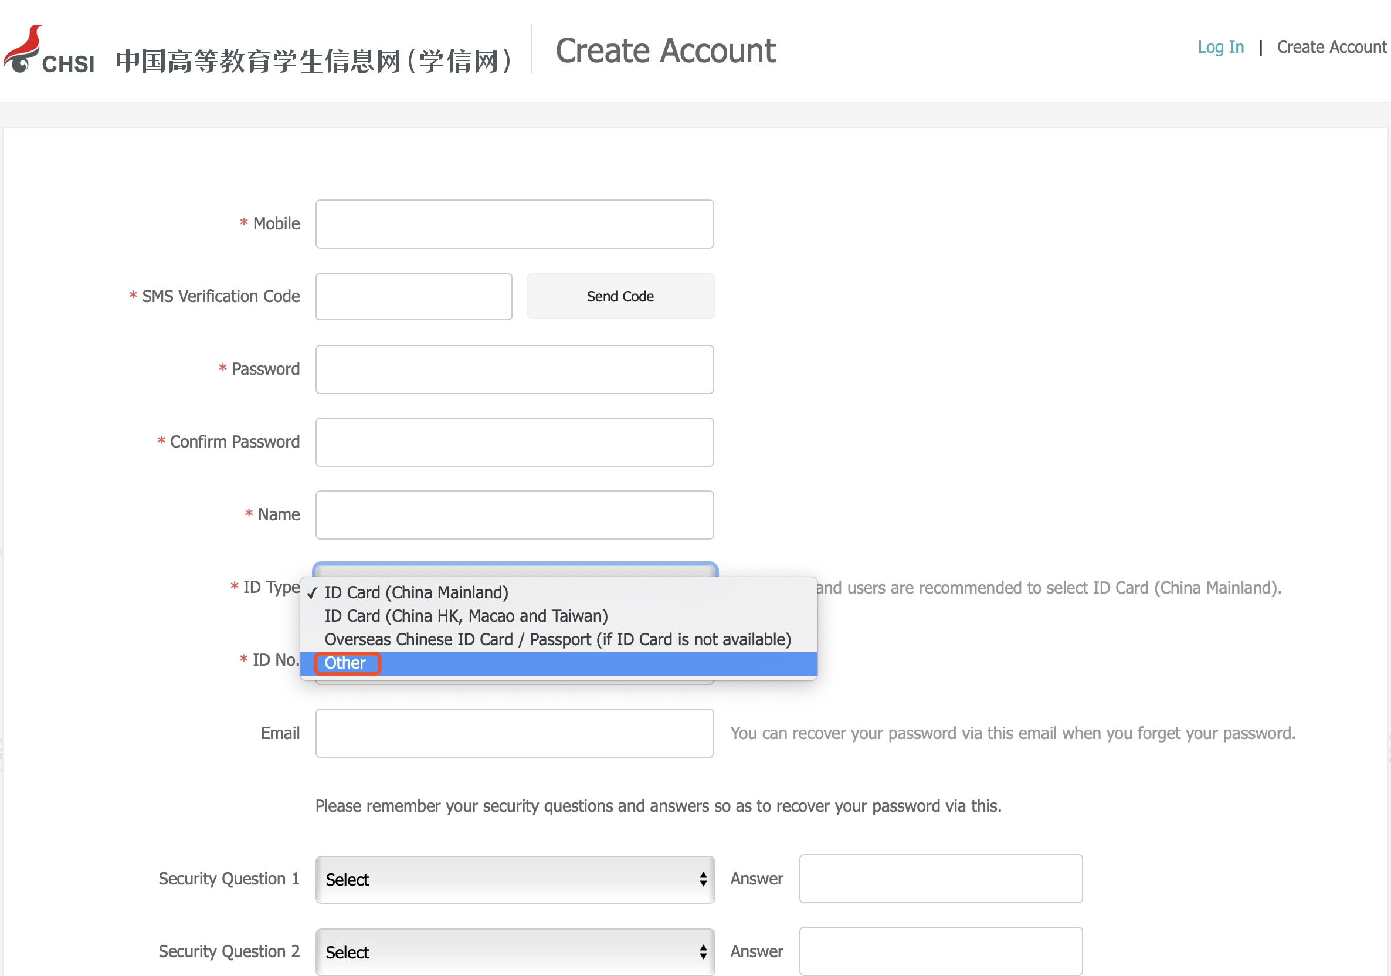
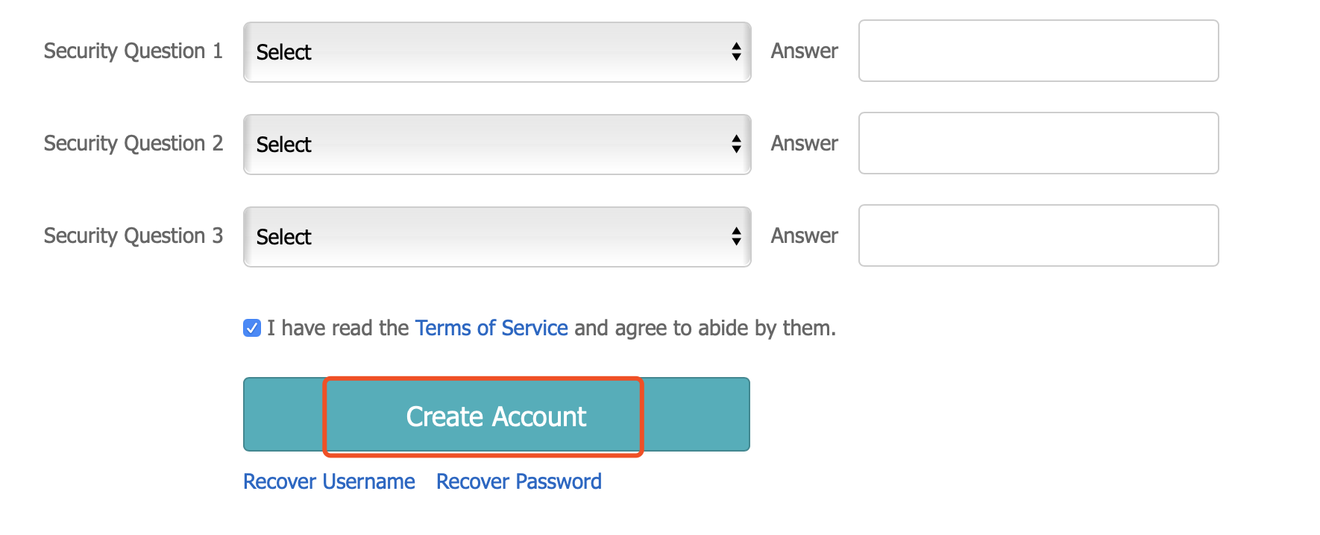
3. 注册成功后，可登陆账号点击 “高等教育信息” 或 “毕业证书图像校对” 查看，就可以看到本人学籍、学历信息了。|After the registration is successful, you can log in to your account and click on “高等教育信息” or “毕业证书图像校对”to view it. You will be able to see your student status and academic information/qualification.
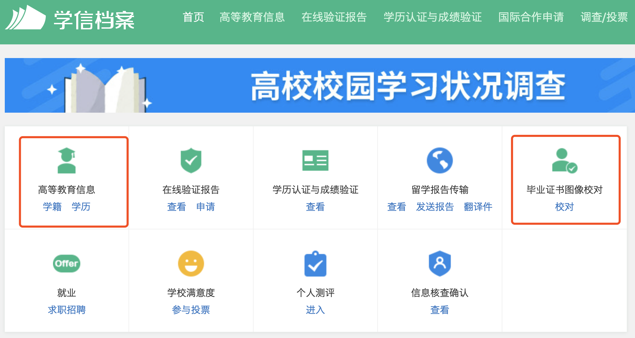
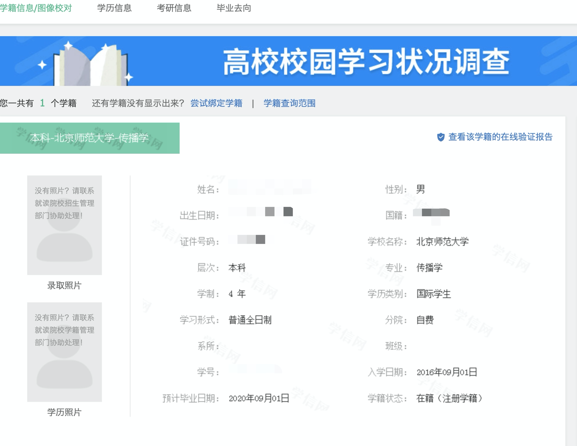
4. 如果不能正常查询学籍、学历，请检查姓名和护照号码，修改姓名或护照号码后，重新登陆账号查看个人学籍学历信息。
If you are unable to check your student status and academic information/qualification, please verify your name and passport number, modify your name or passport number, then log in again to view your personal academic qualifications.
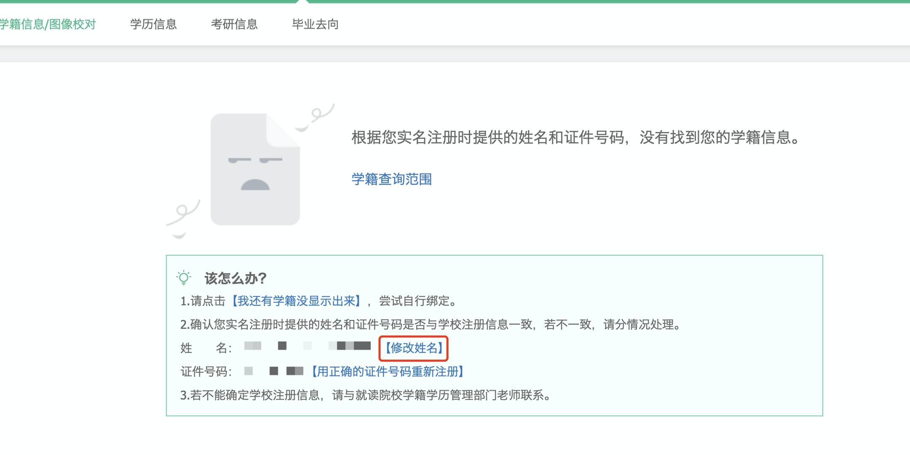
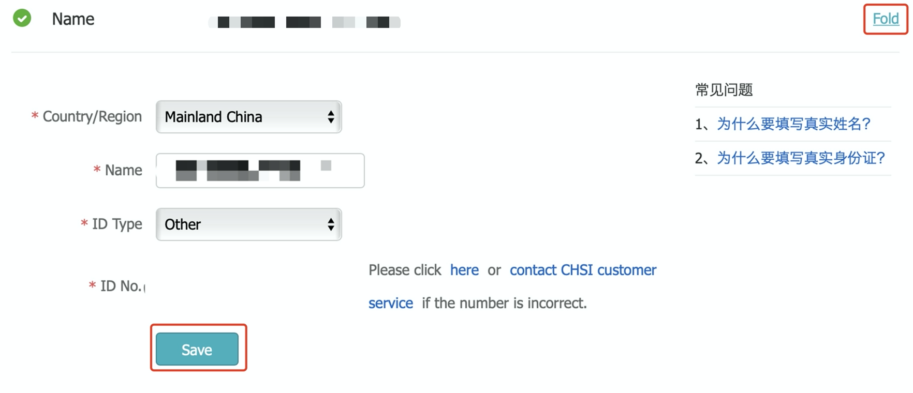
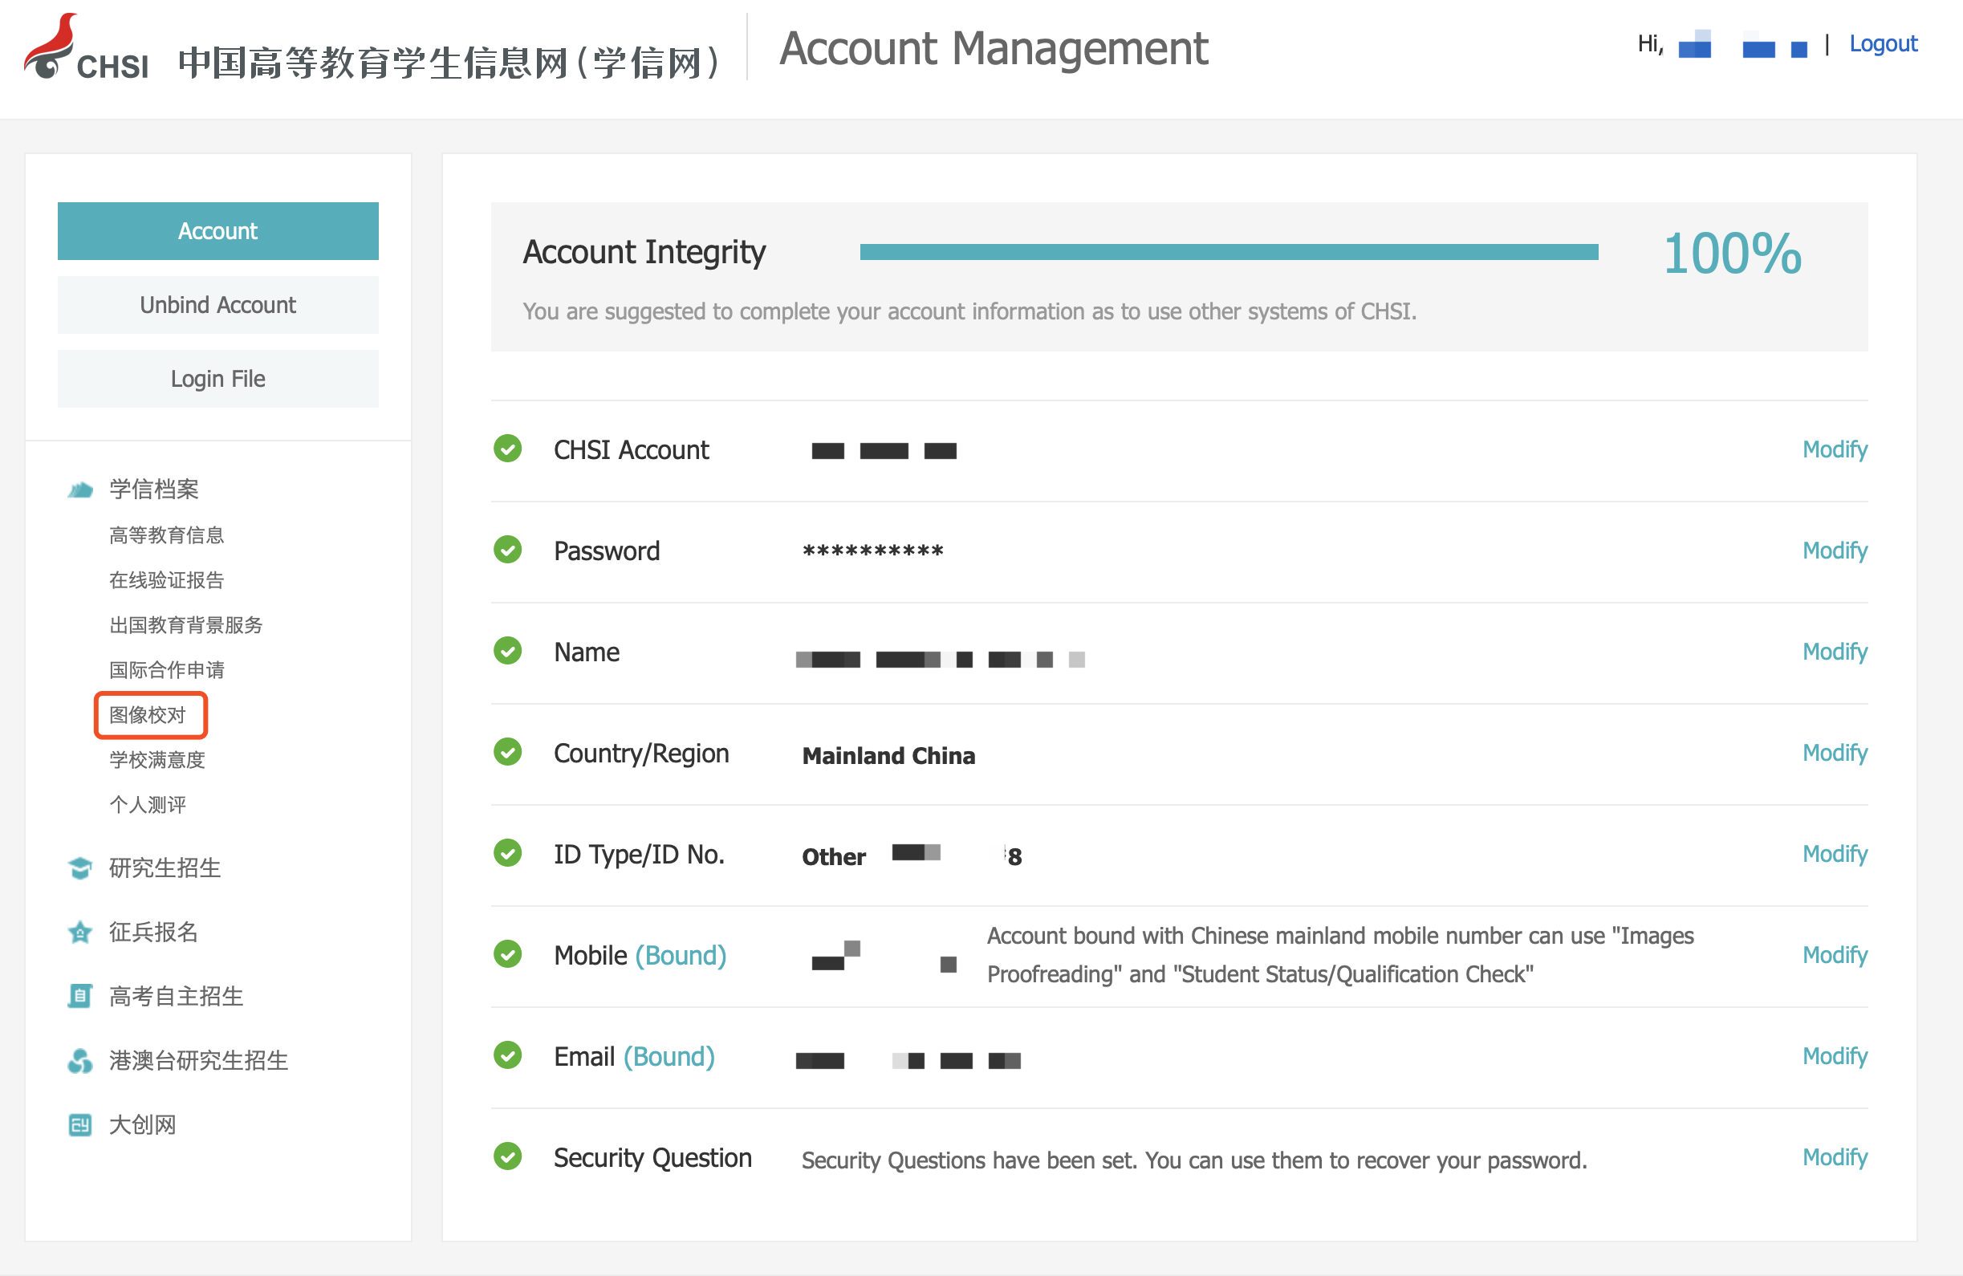

或 | OR

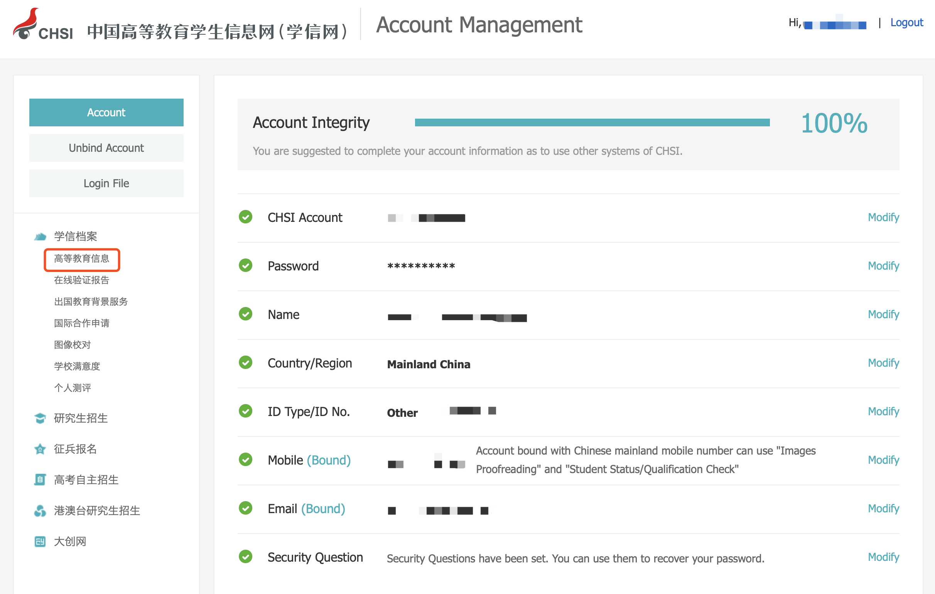

- 如果发现在注册时写错护照号码了，可以通过以: 用新的手机号码和旧护照号码重新注册。
If you realise that you entered the wrong passport number when registering, you can correct it by: Re-registering with a new mobile number the correct passport number.
- 外国留学生的国籍显示为“中国大陆”没有问题，请同学们放心。
The nationality of foreign students is displayed as "Mainland China". Please rest assured that there is no problem with this.
- 若遇到问题，请向所在学部（院、系）教务秘书反馈。
If you encounter any problem other than the above, please contact the teacher in charge of the academic affairs in your faculty, school or college.

中国高等教育学生信息网 | China Higher Education Student Information and Career Center (CHESICC)
学信网客服电话 | Telephone: 010‐82199588
学信网客服邮箱 | Email: kefu@chsi.com.cn

北京师范大学留学生办公室
Beijing Normal University
International Students' Office
2020年04月24日

